RESULTS AND EVALUATION

In this section we will compare the results of the PSO(Particle Swarm Optimization) and the ANT COLONEY Optimization technique , In general in the PSO Algorithm we are getting the better result than the ANT Colony Optimization technique because in the ANT Colony technique the ants position cannot be predicated accurately so we are choosing the ants initial position randomly

Results of the PSO for the various input images ( with different classes , Satellite image , synthetic image ) are compared with the ANT Colony Optimization for the same image

SYNTHETIC IMAGES :

TEST CASE : 1

2-class :

Input image :



This is the input image that we are going to process using PSO technique and ANT colony Optimization technique , this image is created manually with 70\*70 pixels with two colours yellow and green , in this yellow is taken as the one class and blue is taken as other class

Image after Soft Classification :

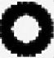

This is the image that we obtain after the soft classification of our input image in this white represents the area where the yellow class is present and black represents the area where the yellow class is not present

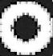

This is the image that we obtain after the soft classification of our input image in this white represents the area where the blue class is present and black represents the area where the blue class is not present

FINAL RESULT AFTER PSO :

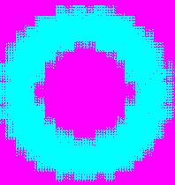

The final image that is obtained is 210\*210 because in this we used scale factor as 3 , and this image is used to test the accuracy of the PSO because only in the synthetic image accuracy can be checked , in this the blue represents the area of the Dark Blue class and rose represents the yellow class areas

Final result after ANT Colony Optimization :

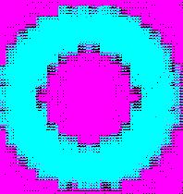

The final image that is obtained is 210\*210 because in this we used scale factor as 3 , and this image is used to test the accuracy of the ANT Colony Optimization because only in the synthetic image accuracy can be checked, in this the blue represents the area of the Dark Blue class and rose represents the yellow class areas and black dots represents the unclassified classes

Comparing PSO and ANT Colony Optimization :

SPEED :

As both the algorithms are ran using the parallel processing results are obtained quicker for the both the techniques but PSO took nearly of 20 sec to process this image and for ANT colony speed cannot be told accurately because speed depends upon the number of the Ants that are generated randomly

ACCURENY :

PSO is more accurate than the ANT colony Optimization technique because in the ANT colony Optimization technique we are getting some classified classes in the synthetic image itself but in the ANT Colony Optimization technique edge are more clear then the PSO algorithm

TEST CASE : 2

3-class :

Input image :



This is the input image that we are going to process using PSO technique and ANT colony Optimization technique , this image is created manually with 10\*10 pixels with three colours black, white and blue , in this balck is taken as the one class , blue is taken as other class and white is taken as other class

Image after Soft Classification :



This is the image that we obtain after the soft classification of our input image in this white represents the area where the black class is present and black represents the area where the black class is not present



This is the image that we obtain after the soft classification of our input image in this white represents the area where the blue class is present and black represents the area where the blue class is not present



This is the image that we obtain after the soft classification of our input image in this white represents the area where the white class is present and black represents the area where the white class is not present

FINAL RESULT AFTER PSO :



The final image that is obtained is 30\*30 because in this we used scale factor as 3 , and this image is used to test the accuracy of the PSO because only in the synthetic image accuracy can be checked, in this the yellow represents the area of the white class , rose represents the areas of dark blue class and blue represents the area of black class

Final result after ANT Colony Optimization :



The final image that is obtained is 30\*30 because in this we used scale factor as 3 , and this image is used to test the accuracy of the ANT Colony Optimization because only in the synthetic image accuracy can be checked , in this the green represents the area of the white class , rose represents the areas of dark blue class and yellow represents the area of black class

Comparing PSO and ANT Colony Optimization :

SPEED :

As both the algorithms are ran using the parallel processing results are obtained quicker for the both the techniques but PSO took nearly of 5 sec to process this image and for ANT colony speed cannot be told accurately because speed depends upon the number of the Ants that are generated randomly

ACCURENY :

PSO is more accurate than the ANT colony Optimization technique because in the ANT colony Optimization technique we are getting some classified classes in the synthetic image itself but in the ANT Colony Optimization technique edge are more clear then the PSO algorithm

TEST CASE : 3

4-class :

Input image :

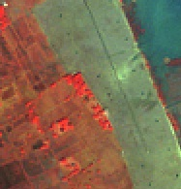

This is the input image that we are going to process using PSO technique and ANT colony Optimization technique , this image is satellite image with 187\*195 pixels, in this 4 class is selected with the different colours

Image after Soft Classification :

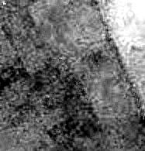

This is the image that we obtain after the soft classification of our input image in this white represents the area where the dark class is present and black represents the area where the dark blue class is not present

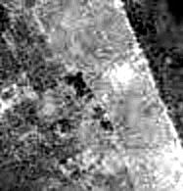

This is the image that we obtain after the soft classification of our input image in this white represents the area where the blue class is present and black represents the area where the blue class is not present

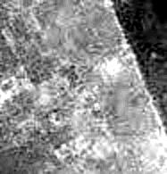

This is the image that we obtain after the soft classification of our input image in this white represents the area where the orange class is present and black represents the area where the orange class is not present

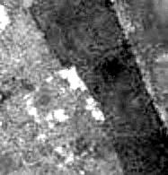

This is the image that we obtain after the soft classification of our input image in this white represents the area where the red class is present and black represents the area where the red class is not present

FINAL RESULT AFTER PSO :

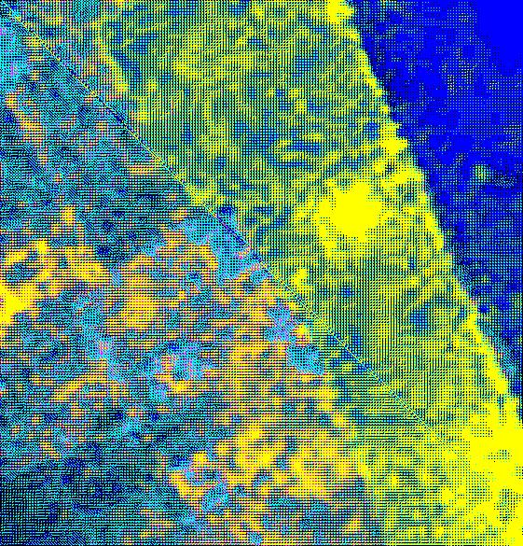

The final image that is obtained is 561\*585 because in this we used scale factor as 3 , and this image is used to test the accuracy of the PSO because only in the synthetic image accuracy can be checked, in this the dark blue represents the area of the dark blue class , yellow represents the areas of blue class, dark yellow represents the area of red class and light blue represents the area of orange class

Final result after ANT Colony Optimization :



The final image that is obtained is 561\*585 because in this we used scale factor as 3 , and this image is used to test the accuracy of the ANT Colony Optimization because only in the synthetic image accuracy can be checked, in this the dark blue represents the area of the dark blue class , yellow represents the areas of blue class, dark yellow represents the area of red class and light blue represents the area of orange class

Comparing PSO and ANT Colony Optimization :

SPEED :

As both the algorithms are ran using the parallel processing results are obtained quicker for the both the techniques but PSO took nearly of 5 sec to process this image and for ANT colony speed cannot be told accurately because speed depends upon the number of the Ants that are generated randomly

ACCURENY :

PSO is more accurate than the ANT colony Optimization technique because in the ANT colony Optimization technique we are getting some classified classes but in the ANT Colony Optimization technique edge are more clear then the PSO algorithm

Satellite Image :

TEST CASE : 4

4-class :

Input image :

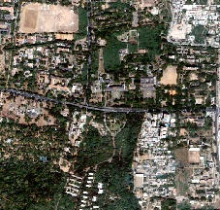

This is the input image that we are going to process using PSO technique and ANT colony Optimization technique , this image is satellite image with 227\*216 pixels, in this 1 class is selected which represents the buildings

Image after Soft Classification :

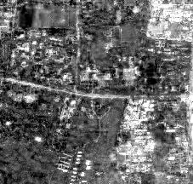

This is the image that we obtain after the soft classification of our input image in this white represents the area where the building class is present and black represents the area where the building blue class is not present

FINAL RESULT AFTER PSO :

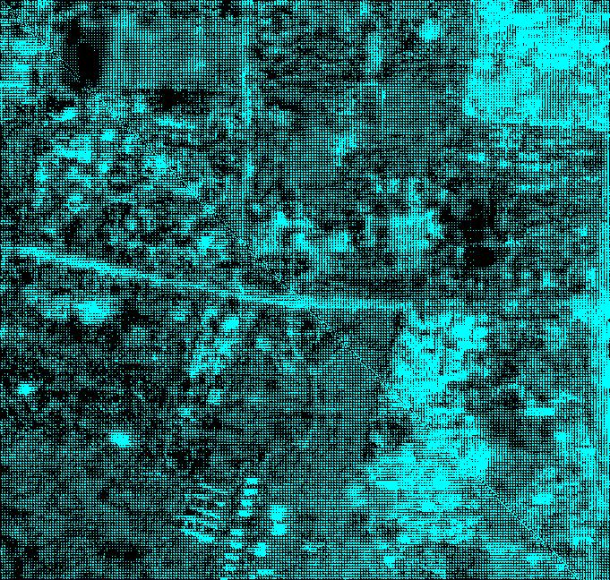

The final image that is obtained is 681\*685 because in this we used scale factor as 3 , and this image is used to test the accuracy of the PSO because only in the synthetic image accuracy can be checked , in this the blue represents the area of the building class ,

Final result after ANT Colony Optimization :



The final image that is obtained is 561\*585 because in this we used scale factor as 3 , and this image is used to test the accuracy of the ANT Colony Optimization because only in the synthetic image accuracy can be checked, in this the light blue represents the area of the dark building class

Comparing PSO and ANT Colony Optimization :

SPEED :

As both the algorithms are ran using the parallel processing results are obtained quicker for the both the techniques but PSO took nearly of 5 mins to process this image and for ANT colony speed cannot be told accurately because speed depends upon the number of the Ants that are generated randomly

ACCURENY :

PSO is more accurate than the ANT colony Optimization technique because in the ANT colony Optimization technique we are getting some classified classes but in the ANT Colony Optimization technique edge are more clear then the PSO algorithm

TEST CASE : 5

2-class satellite image :

Input image :



This is the input image that we are going to process using PSO technique and ANT colony Optimization technique , this image is satellite image with 227\*216 pixels, in this 2 class is selected which represents the buildings and grass area

Image after Soft Classification :



This is the image that we obtain after the soft classification of our input image in this white represents the area where the building class is present and black represents the area where the building blue class is not present

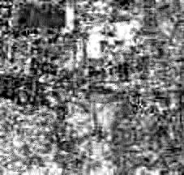

This is the image that we obtain after the soft classification of our input image in this white represents the area where the grass class is present and black represents the area where the building grass class is not present

FINAL RESULT AFTER PSO :

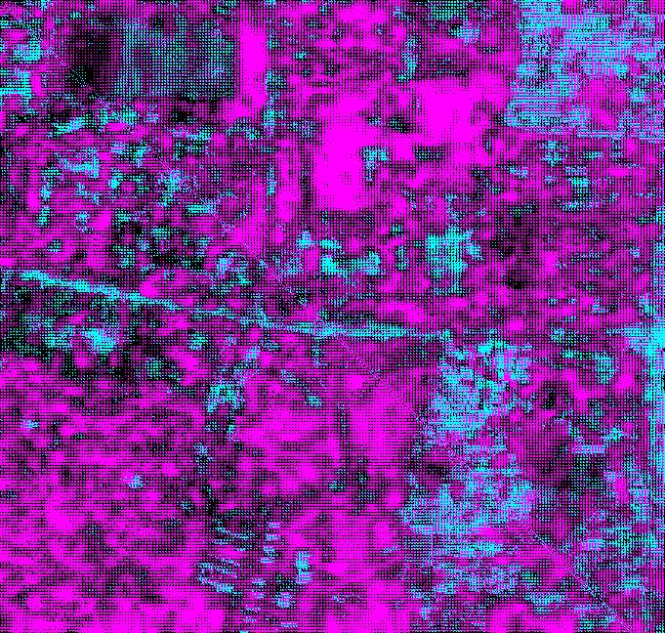

The final image that is obtained is 681\*685 because in this we used scale factor as 3 , and this image is used to test the accuracy of the PSO because only in the synthetic image accuracy can be checked, in this the blue represents the building class and rose represents the area of grass class

Final result after ANT Colony Optimization :



The final image that is obtained is 561\*585 because in this we used scale factor as 3 , and this image is used to test the accuracy of the ANT Colony Optimization because only in the synthetic image accuracy can be checked, in this the blue represents the building class and rose represents the area of grass class

Comparing PSO and ANT Colony Optimization :

SPEED :

As both the algorithms are ran using the parallel processing results are obtained quicker for the both the techniques but PSO took nearly of 7 mins to process this image and for ANT colony speed cannot be told accurately because speed depends upon the number of the Ants that are generated randomly

ACCURENY :

PSO is more accurate than the ANT colony Optimization technique because in the ANT colony Optimization technique we are getting some classified classes but in the ANT Colony Optimization technique edge are more clear then the PSO algorithm

TEST CASE : 6

3-class satellite image :

Input image :



This is the input image that we are going to process using PSO technique and ANT colony Optimization technique , this image is satellite image with 227\*216 pixels, in this 3 class is selected which represents the buildings , grass and land area

Image after Soft Classification :



This is the image that we obtain after the soft classification of our input image in this white represents the area where the building class is present and black represents the area where the building blue class is not present



This is the image that we obtain after the soft classification of our input image in this white represents the area where the grass class is present and black represents the area where the building grass class is not present

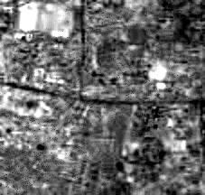

This is the image that we obtain after the soft classification of our input image in this white represents the area where the land class is present and black represents the area where the building land class is not present

FINAL RESULT AFTER PSO :

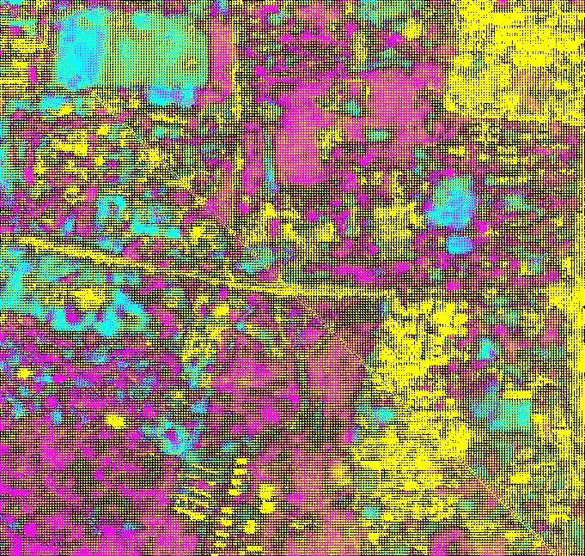

The final image that is obtained is 681\*685 because in this we used scale factor as 3 , and this image is used to test the accuracy of the PSO because only in the synthetic image accuracy can be checked

Final result after ANT Colony Optimization :

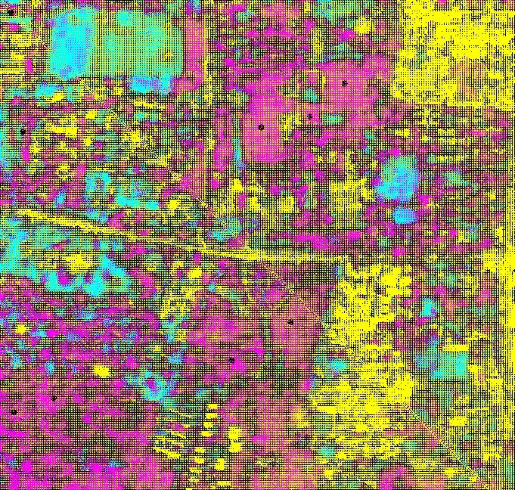

The final image that is obtained is 561\*585 because in this we used scale factor as 3 , and this image is used to test the accuracy of the ANT Colony Optimization because only in the synthetic image accuracy can be checked, in this the yellow represents the building class, rose represents the area of grass class and blue represents the land area

Comparing PSO and ANT Colony Optimization :

SPEED :

As both the algorithms are ran using the parallel processing results are obtained quicker for the both the techniques but PSO took nearly of 10 mins to process this image and for ANT colony speed cannot be told accurately because speed depends upon the number of the Ants that are generated randomly

ACCURENY :

PSO is more accurate than the ANT colony Optimization technique because in the ANT colony Optimization technique we are getting some classified classes but in the ANT Colony Optimization technique edge are more clear then the PSO algorithm